We affirm that the two coauthors of our manuscript (“Resting energy expenditure of women with and without polycystic ovary syndrome: a systematic review and meta-analysis”) who do not have institutional email addresses (Alyssa Olenick and Georgia Kohlhoff) are who they present themselves to be, and that they meet the authorship criteria of the Journal of Clinical Endocrinology & Metabolism.
Signature: | 
Email: | r.p.kirwan@ljmu.ac.uk
Signature: | 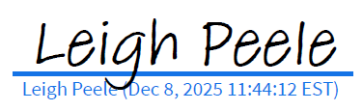
Email: | leigh@macrofactorapp.com
Signature: | 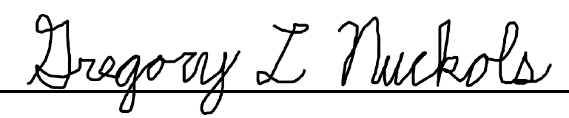
Email: | greg@macrofactorapp.com
Signature: | 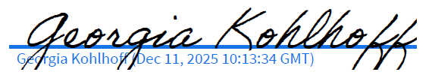
Email: | g_kohlhoff@hotmail.co.uk
Signature: | 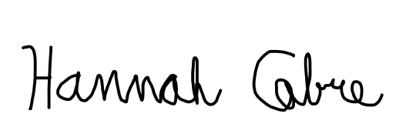
Email: | hannah.cabre@pbrc.edu
Signature: | 
Email: | alyssaolenickphd@gmail.com
Signature: | 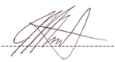
Email: | james@steele-research.com

